Case report
Vertical root fracture: Ahidden menance
1.Bhawna Garg, 2. Bhagyesh Cheta ,3. Priyanka Ratia,4. Dr. Girish Parmar,5. Dr Abhishek Parmar, 6 .Dr Nupur Dhanak

Department of Conservative Dentistry and Endodontics
Corresponding author : Dr. Girish Parmar

ABSTRACT:
Vertical fractures in teeth can present difficulties in diagnosis. However there are numerous peculiar clinical and radiological features that, might suggest the presence of such type of fractures. This case report presents a case in which no such indicators of presence of a vertical root fracture was evident either clinically or radiographically. It was not even revealed in a CBCT examination too. Only symptom was recurring pain and swelling in a previously treated tooth. Therefore, surgical exploration of the region of swelling and pain was done that revealed the presence of a vertical root fracture. Unfortunately the labial cortical plate was completely resorbed leading to dehiscence, the tooth couldn’t be salvaged and was extracted.
INTRODUCTION:
Root cracks and fractures are among the most frustrating aspects of clinical restorative and/or endodontic practice. Out of all the root fractures, Longitudinal root fractures (described as cracked tooth, split tooth, vertical root fracture by American Association of Endodontics) pose a great diagnostic and treatment challenge. Unlike the other tooth fractures occurring due to impact trauma, these cracks and fractures tend to grow and change with time.(1) Apart from that, these fracture lines have potential for bacterial penetration that can lead to inflammation and destruction of periodontal attachment apparatus and ultimately loss of the involved tooth.
Therefore prevention of a potential crack or fracture is a fundamental principle, and early detection is always desirable in routine clinical practice.(2) A vertical root fracture (VRF) is a longitudinally oriented complete or incomplete fracture initiated in the root at any level and is usually directed buccolingually. The fracture is located in the root portion of the tooth only, and may extend coronally toward the cervical periodontal attachment(
Patients with VRF pose a challenging clinical situation to diagnose as they present minimal signs & symptoms and therefore often go undetected until any periodontal pathosis manifests. The symptoms can be either vague or specific, yet they are often insufficient for a definitive diagnosis; the radiographic evaluation can be elusive as only rarely will there be visible separation of the segments. Previous studies in the literature have shown that invariably all the teeth with VRF has a history of previous endodontic treatment. Having a sinus tract and a narrow, isolated periodontal probing defect in association with a tooth that has had root canal treatment, with or without a post placement, is considered to be pathognomonic for the presence of a VRF

Post-treatment apical periodontitis is caused by either persistent or secondary intraradicular infection. Persistent infections are caused if initial endodontic therapy does not adequately disinfect the canal or doesn’t entomb those bacteria that may survive inside the canal.(3) However secondary infections are mainly caused by coronal leakage in the already obturated root canals occurring due to loss of the permanent coronal restoration or a vertical tooth fracture. This type of Recurrent disease often represents a late failure of the endodontic treatment.This case describes such a late failure of endodontic treatment as characterized by recurrent post treatment.
CASE REPORT
A 22 years old female patient reported to the department of Conservative Dentistry and Endodontics with a complaint of pain and swelling in upper front tooth region. Patient had a history of trauma due to fall 12 years ago but since patient was completely asymptomatic, she didn’t seek any dental treatment at the time of injury. However she had a history of previous endodontic treatment in tooth #8 because of an acute apical abscess 7 years ago, Treatment consisted of instrumentation with 1% NaOCl irrigation, calcium hydroxide interappointment medication and final obturation by lateral compaction of gutta-percha in tooth #8. Clinical Examination revealed a localized gingival inflammation in region of #8 with no signs of pus discharge or sinus tract formation(Fig. 1 A). However the gingiva at the same site i.e. #8 was tender to palpation and tooth was tender to percussion. Radiographic Examination showed a open apex in tooth #7 and obturation with gutta percha in tooth #8 without and significant widening of periodontal ligament space and/or any apical radiolucency. Based upon the present clinical & Radiographic findings, final diagnosis of ‘Previously Treated tooth with Symptomatic Apical Periodontitis’ in #8 and ‘Previously Initiated Treatment with Asymptomatic Apical Periodontitis’ in tooth #7 was made. No relevant history was seen.

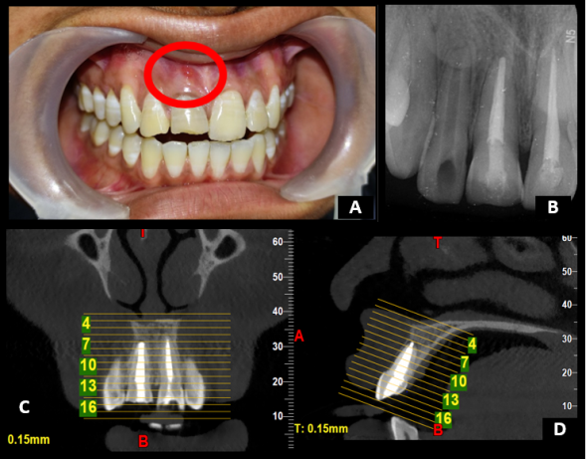

Fig. 1 : Preoperative clinical Photo showing localized gingival inflammation in tooth #8(A), IOPA
shows Previously Treated Tooth #8(B), CBCT Examination -Coronal (C) & Sagittal(right) View(D)

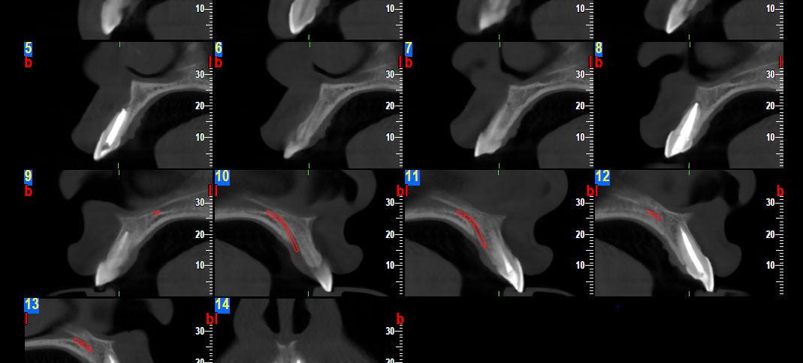

Fig 2 : Sagittal View of CBCT at different slices (White Arrows showing a complete loss of labial cortical plate in tooth #8 & Red Arrow showing periapical radiolucency at the apex of tooth #8)

Patient was explained about the endodontic retreatment as a conservative option for the management of the same. Patient was reluctant for retreatment and insisted on a definitive treatment.

Since there was signs of periodontal pocket or bleeding on probing on buccal or palatal site with normal gingival sulcular depth that was extraneous to the CBCT findings, an exploratory surgery was suggested as treatment option. Since tooth #7 was completely asymptomatic, an orthograde apexification was performed with MTA(MTA Plus^{R} Prevest Denpro) before the surgical exploration. Patient was recalled after 1 week for surgical exploration.

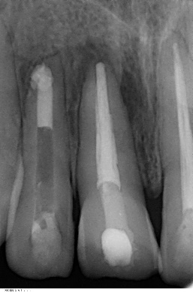
Fig 3 : After MTA Apexification

At the time of surgery, topical anesthetic gel was applied before administration local anesthesia. An infraorbital nerve block on both side and nasopalatine nerve block was given by administration of 1.5 ml of Lignocaine Hydrochloride with Adrenaline at 1:1,00,000 dilution. After that a crevicular incision was made extending from distal of tooth #6 to mesial of tooth #10 and two vertical releasing incisions were given with blade no. 11 to get a rectangular flap for adequate accessibility and visibility of the affected site. A full thickness mucoperiosteal flap was elevated using a periosteal elevator no. 11 and surgical site was exposed.(Fig 4).

After the flap reflection the site was cleaned to explore the surgical site. Complete dehiscence of the tooth no. #8 and #7 with loss of labial cortical plate was observed exposing the buccal surface of the roots of tooth #8 and #7. After irrigating the site with normal saline, a vertical fracture line was noticed on the buccal surface of tooth #8. Methylene blue staining was used to confirm the presence of vertical root fracture.(Fig. 4D)

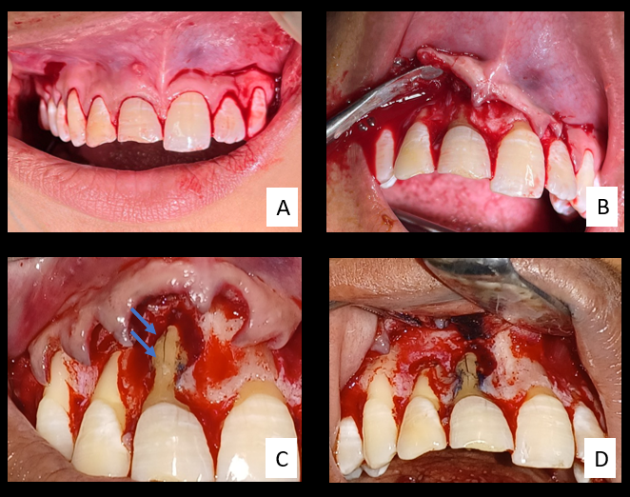

Fig 4 : Intraoperative photos : (A) Crevicular Incision (B) Reflection of full thickness flap (C) Vertical Root Fracture (D) Confirmation of VRF with Methylene blue staining

Owing to the loss of the labial cortical plate along with presence of vertical root fracture, the only predictable treatment option was extraction of tooth #8. Patient was explained about the prognosis of the tooth and after taking the informed consent from patient, tooth no. #8 was extracted and extraction socket was debrided with a bone curette to remove any underlying pathology and apicectomy was performed in tooth #7. (Fig 5)

The surgical site was finally irrigated with the Povidone Iodine solution with a final wash with normal saline. Simple interrupted sutures with 3-0 black braided silk material were given. Patient was prescribed a chlorhexidine Mouth wash and Antibiotic prophylaxis for 5 days and was recalled for removal of sutures after 1 week. Post operative Analgesics and Anti-Inflammatory were also prescribed.
The extracted with VRF was kept in 10%formalin solution and was cleaned and disinfected for careful examination of the fracture line and its extent using magnifying loupes at 3x magnification. No other anomaly was observed except for the vertical root fracture.
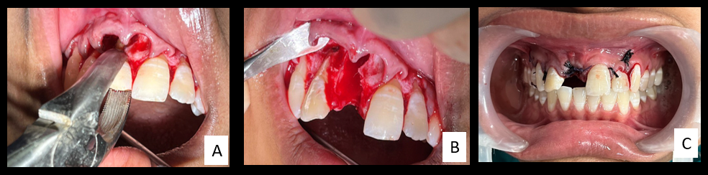

Fig 5: (A) Extraction of tooth #8 (B)Apicectomy of tooth #7 (C) Post operative after suturing

DISCUSSION:
Vertical root fractures are described as longitudinally oriented fractures of root that can be divided into complete and incomplete vertical root fractures based on the separation of the two fragments according to Leubke’s classification(4) VRFs can be present in endodontically treated or in a nonrestored tooth with parafunctional habits such as bruxism and/or clenching. Typically, VRF starts inside the root canal wall and extends to the outer root surface of root in a bucco-lingual direction and thus the fracture might involve one surface (buccal or lingual) or both surfaces (buccal and lingual). These fractures may harm the root or extend coronally near the cervical periodontal attachment.(5) Some studies in the previous literature, infact, have concluded VRFs to be the third most common cause of tooth loss after dental caries and refractory periodontal diseases.(6,7). Because there are minimal to no signs and symptoms in a patient with VRF of a tooth, they often go unnoticed and undiagnosed. Its only few cases of VRF that present with signs of tenderness, localized gingival inflammation, I/O sinus tract and/or a deep periodontal pocket.(8) Apart from the vague signs and symptoms, ‘an angular pattern of apical or lateral bone resorption with a J-shaped radiolucent halo’ is considered as a pathognomic of VRFs.(9).
Cone Beam Computed Tomography has also been suggested as a diagnostic aid in the detection of VRFs. Nevertheless, the diagnostic accuracy is still questionable as seen in this case. Vertical root fracture was not identified in any of the three sections. Since it usually occurs in a bucco-lingual direction, an axial section of CBCT can be expected to reveal the same. However CBCT examination failed at locating the fracture line. (Fig )
The only predictable treatment is removal of the fracture root or extraction of the tooth(1) Bacterial infection in the fracture line and the resorption of an adjacent alveolar bone are the main causes of extraction.(10) However, Intentional reimplantation after sealing the fractured site by a adhesive resin or a more biocompatible material like biodentin is being practiced as a conservative alternative of extraction after VRF. (11). However due to the presence of complete dehiscence of the labial cortical bone plate in tooth #8, intentional reimplantation couldn’t be possible owing to poor prognosis. Therefore extraction of tooth #8 was chosen as the treatment of choice and apicectomy in tooth #7 followed by replacement of extracted tooth by fixed dental prosthesis and/or by implant placement depending upon the osseous healing along with patient preference.

REFERENCES:
- American Association of Endodontists: Cracking the cracked tooth code: detecting and treatment of various longitudinal tooth fractures. Endodontics; colleagues for excellence, Chicago, summer 2008, American Association of Endodontists
- Cohen’s Pathways of the pulp, 11th edition, pg 793
- Ricucci D, Siqueira Jr JF. Recurrent apical periodontitis and late endodontic treatment failure related to coronal leakage: a case report. Journal of endodontics. 2011 Aug 1;37(8):1171-5.
- Dhawan A, Gupta S, Mittal R. Vertical root fractures: An update review. Journal of Restorative Dentistry. 2014 Sep 1;2(3):107.
- W.-C. Liao, Y.-L. Tsai, C.-Y. Wang et al., “Clinical and Radiographic characteristics of vertical root fracture in endodontically and nonendodontically treated teeth,” Journal of Endodontics, vol. 43, no. 5, pp. 687–693, 2017.
- N. Takeuchi, T. Yamamoto, T. Tomofuji, and C. Murakami, “A retrospective study on the prognosis of teeth with root fracture in patients during the maintenance phase of periodontal therapy,” Dental Traumatology, vol. 25, no. 3, pp. 332–337, 2009
- C. Garc´ıa-Guerrero, C. Parra-Junco, S. Quijano-Guauque, N. Molano, G. A. Pineda, and D. J. Mar´ın-Zuluaga, “Vertical root fractures in endodontically- treated teeth: a retrospective analysis of possible risk factors,” Journal of Investigative and Clinical Dentistry, 2017, in press.
- Kallel I, Moussaoui E, Chtioui F, Douki N. diagnosis and managment of maxillary incisor with vertical root fracture: A clinical report with three-year follow-up. Case reports in dentistry. 2018 Feb 6;2018.
- L. Karygianni, M. Krengel, M. Winter, S. Stampf, and K. T. Wrbas, “Comparative assessment of the incidence of vertical root fractures between conven- tional versus surgical endodontic retreatment,” Clinical Oral Investigations, vol. 18, no. 8, pp. 2015–2021, 2014.
- N. Tani-Ishii, N. Mutoh, K. Muromachi, and J. Suzuki, “The clinical evaluation of vertical root fracture after endodontic treatment with mineral trioxide aggregate,” Integrative Molecular Medicine, vol. 4, no. 3, pp. 1–5, 2017
- Hadrossek PH, Dammaschke T. New treatment option for an incomplete vertical root fracture–a preliminary case report. Head & face medicine. 2014 Dec;10(1):1-7.

